TRADER (ORACLE) TESTING

1. To view your reports, you will need to click on **View Report** button in the **Trader Panel**

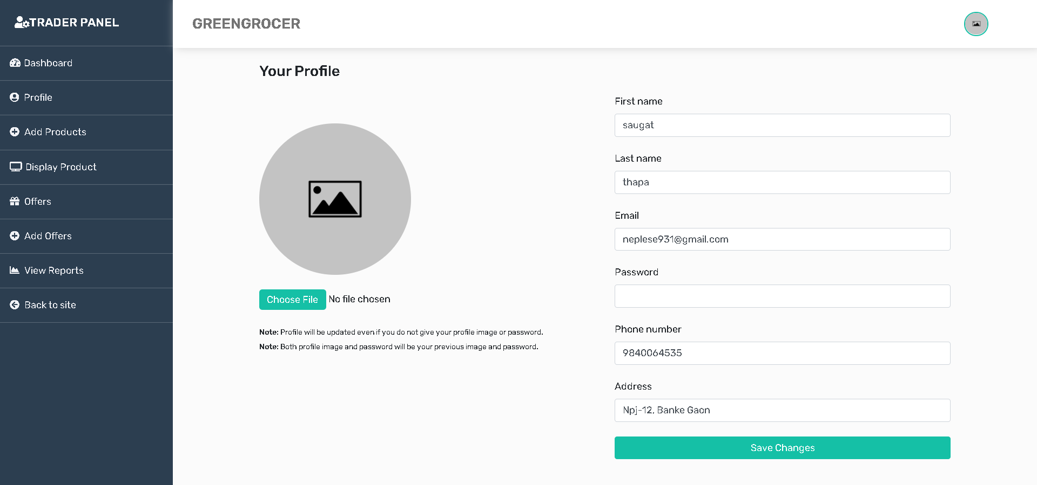

1. Clicking on this button will get you to the **login page** of Oracle Apex. You need to sign in with your trader login credentials(oracle).

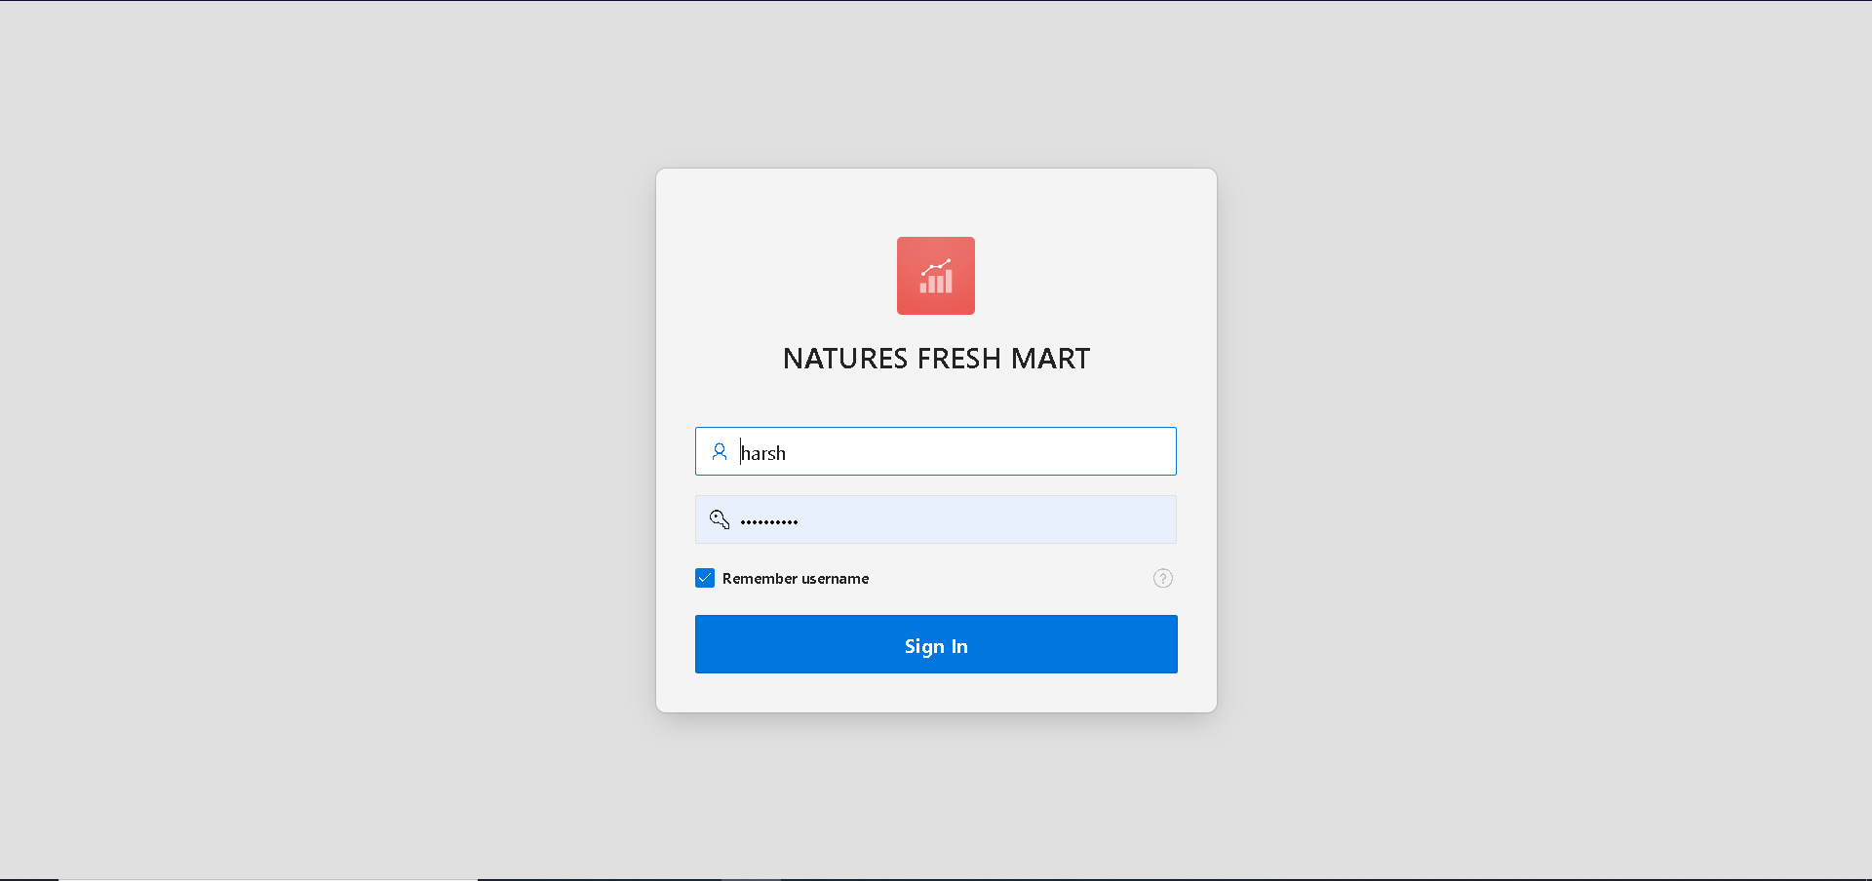

Invalid Login

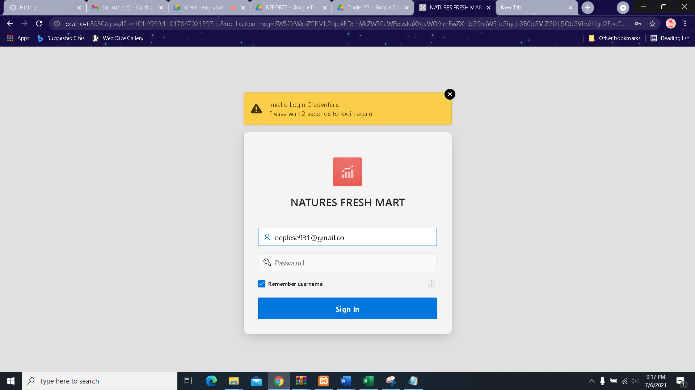

1. Once correct login credentials are filled, it’ll take you to your Oracle Apex Trader dashboard which contains information about the highest sold products, highest grossing products, monthly orders and pending orders which looks like this

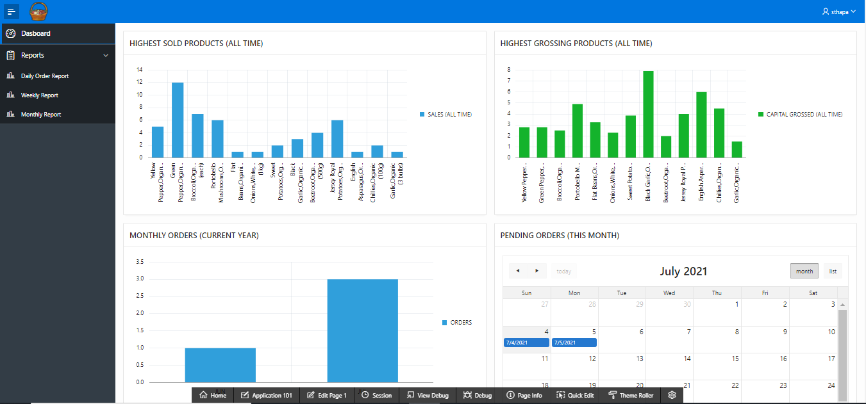

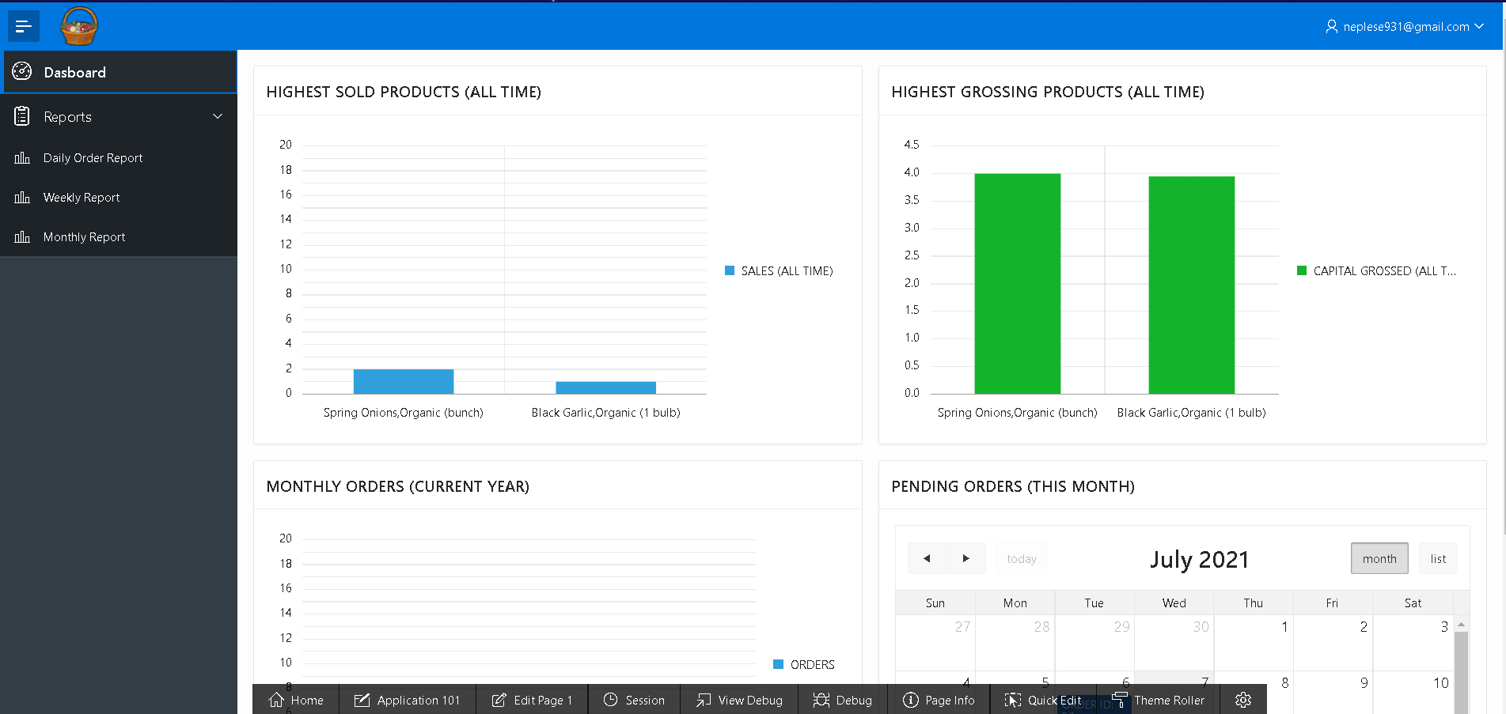

1. You have access to the **daily order report**, **weekly financial report** and **monthly sales report** whose screenshots are given below respectively:

**DAILY ORDER REPORT**

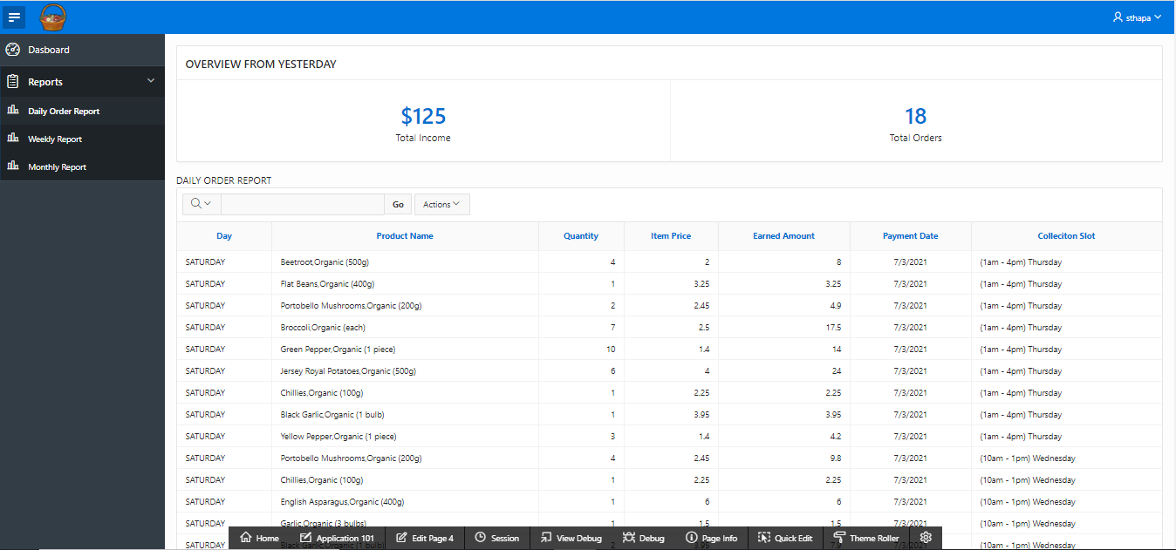

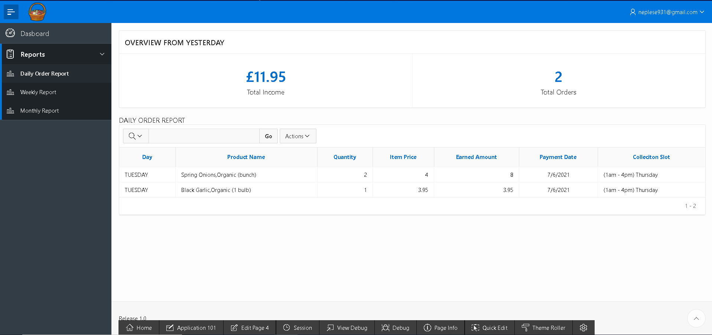

**WEEKLY FINANCIAL REPORT**

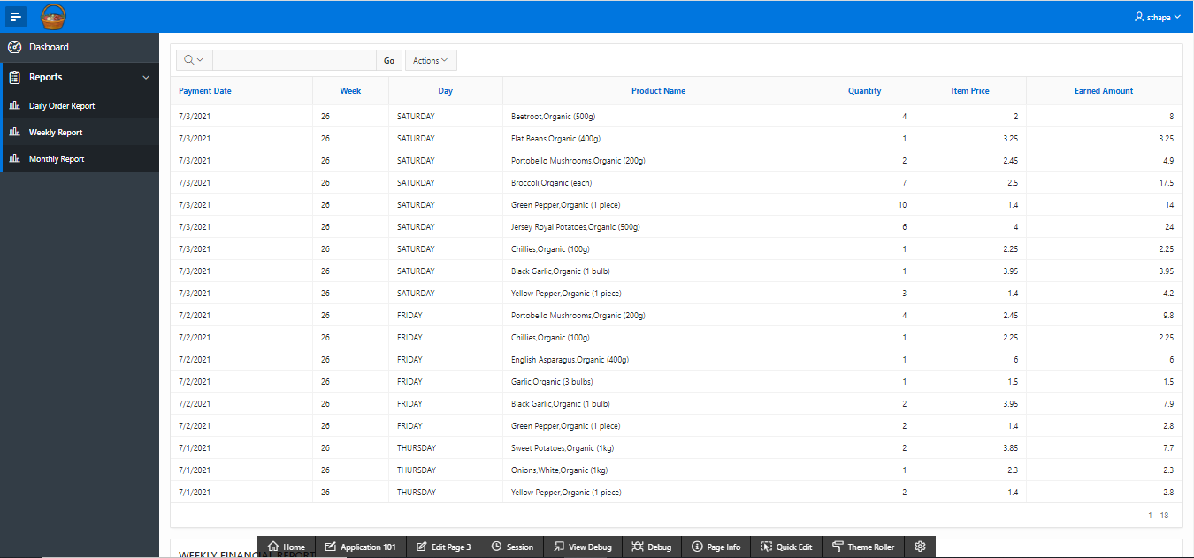

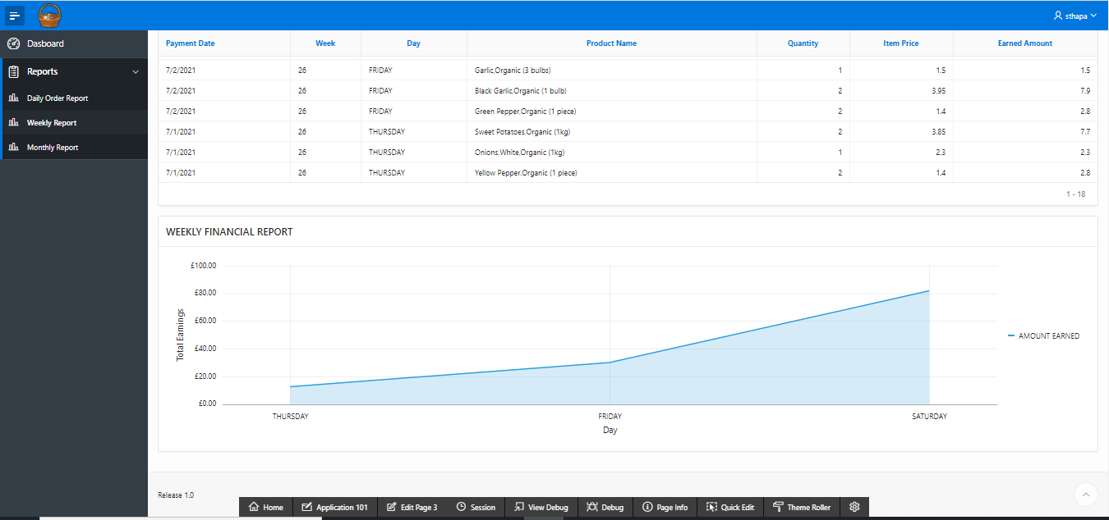

**MONTHLY SALES REPORT**

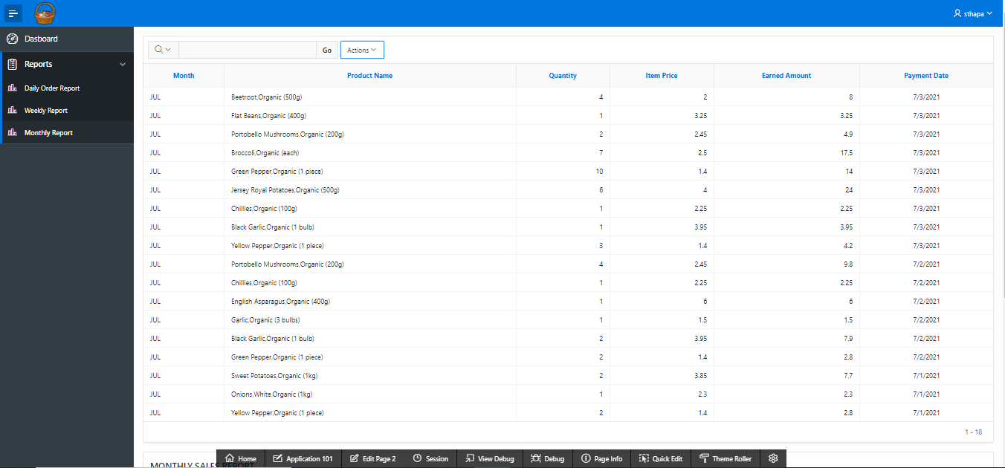

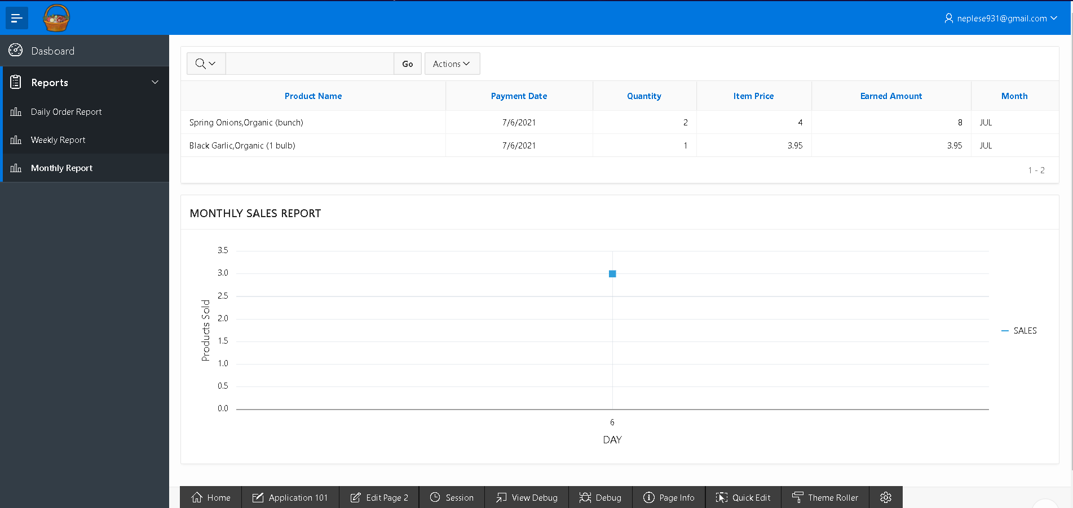

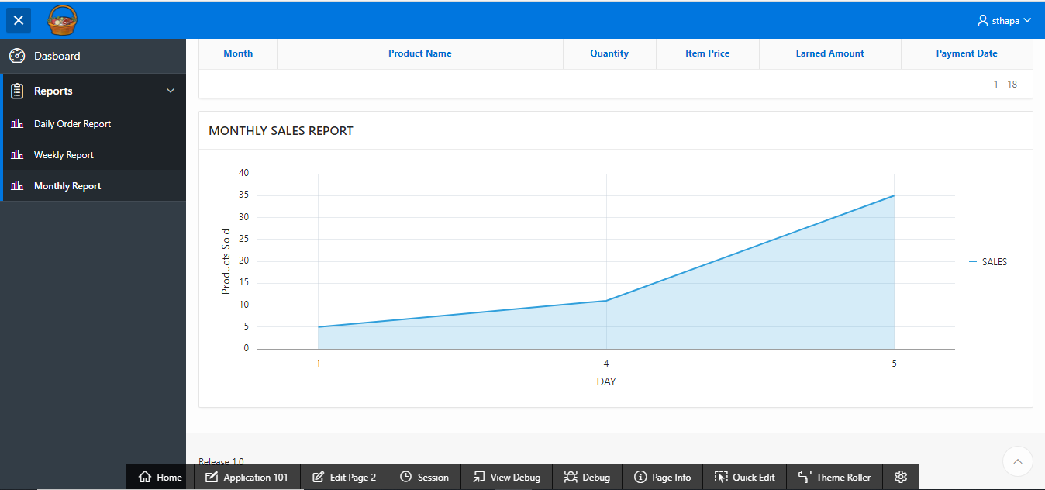

1. To logout, click the button with your name (Trader’s name) on the top right, click on sign out option.

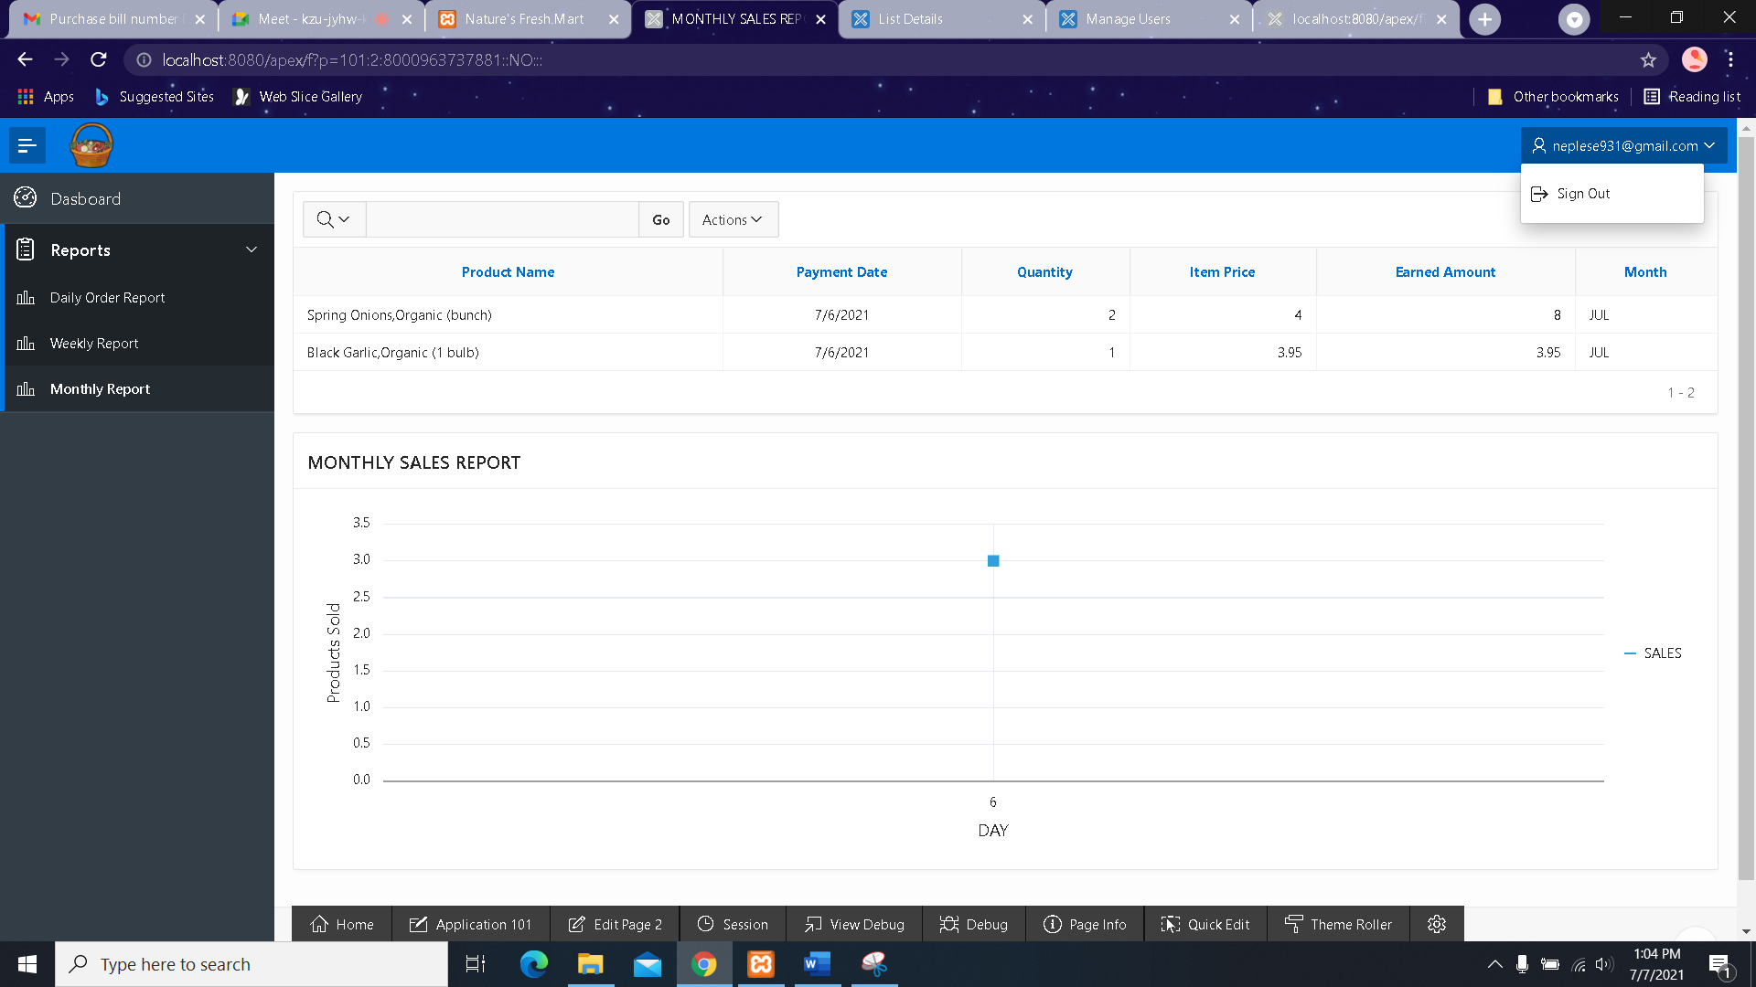

After sign out, trader is directed to oracle login page

